صورة تحتوي على توضيح, رسوم متحركة, قصاصة فنية, التصميم

تم إنشاء الوصف تلقائياً بثقة متوسطةصورة تحتوي على دائرة, رسوم متحركة

تم إنشاء الوصف تلقائياً

Names: Shady Mohamed Abdel Gawad ID: 20200246

Names: Mohamed Ayman Eze El regal ID: 20200432

Subject: Topics in Information Technology-2

(Cloud Computing)‬‏

Under the supervision of: Dr/ Nour Mahmoud

Lab Assignment: 1

Group: S1

1. **Part 1 search report:**

**1. What are the differences between virtualization and containerization?**

**Resource Isolation: Virtualization isolates the entire operating system for each virtual machine (VM). Containers share the host operating system's kernel, isolating applications from each other but not the underlying system.**

**Operating System: VMs require a full guest operating system to be installed. Containers leverage the host's kernel, reducing resource consumption.**

**Performance: VMs can be slower to start and consume more resources due to guest OS overhead. Containers are lightweight and start up faster.**

**Use Cases: VMs are ideal for running applications requiring specific operating systems or for complete system isolation. Containers excel at deploying microservices and portable applications within a shared environment.**

**2. What is the architecture of a virtual machine and a container?**

**Virtual Machine Architecture:**

**Physical Hardware: The underlying physical server.**

**Hypervisor: Software that creates and manages VMs, providing a virtual layer above the hardware.**

**Guest Operating System: The operating system installed within each VM.**

**Application: The software running on the guest OS.**

**Container Architecture:**

**Physical Hardware: The underlying physical server.**

**Host Operating System: The main operating system running on the server.**

**Container Engine (e.g., Docker): Software that manages containers.**

**Container Image: A lightweight, executable package containing the application and its dependencies.**

**Container: An isolated instance of a container image running on the host OS.**

**3. What is Docker?**

**Docker is a popular open-source platform for developing, deploying, and managing applications using containers. It provides tools for building container images, running containers, and sharing them across environments.**

**4. What is a Docker file, Docker image, and Docker container?**

**Docker file: A text file containing instructions for building a Docker image. It specifies the base operating system, dependencies, and application code to be included in the image.**

**Docker Image: A read-only template that encapsulates the application code, configuration files, and dependencies required to run the application. It's essentially a blueprint for creating containers.**

**Docker Container: A running instance of a Docker image. It provides an isolated environment for the application to execute. Multiple containers can be created from a single image.**

**5. Differences between Kubernetes and Docker?**

**Purpose: Docker focuses on building, sharing, and running individual containers. Kubernetes is a container orchestration platform that manages the deployment, scaling, and networking of containerized applications. It allows you to automate container deployments across clusters of machines.**

**Scope: Docker deals with individual containers. Kubernetes manages the entire lifecycle of containerized applications at scale.**

**Complexity: Docker is simpler to learn and use. Kubernetes requires a deeper understanding of container orchestration principles.**

1. **Part 2 Lab task:**

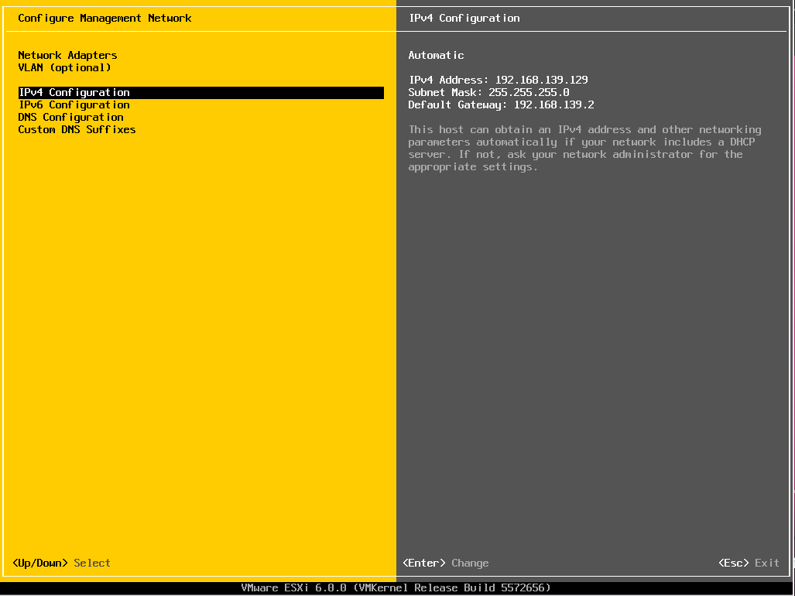

**ESXi configuration**

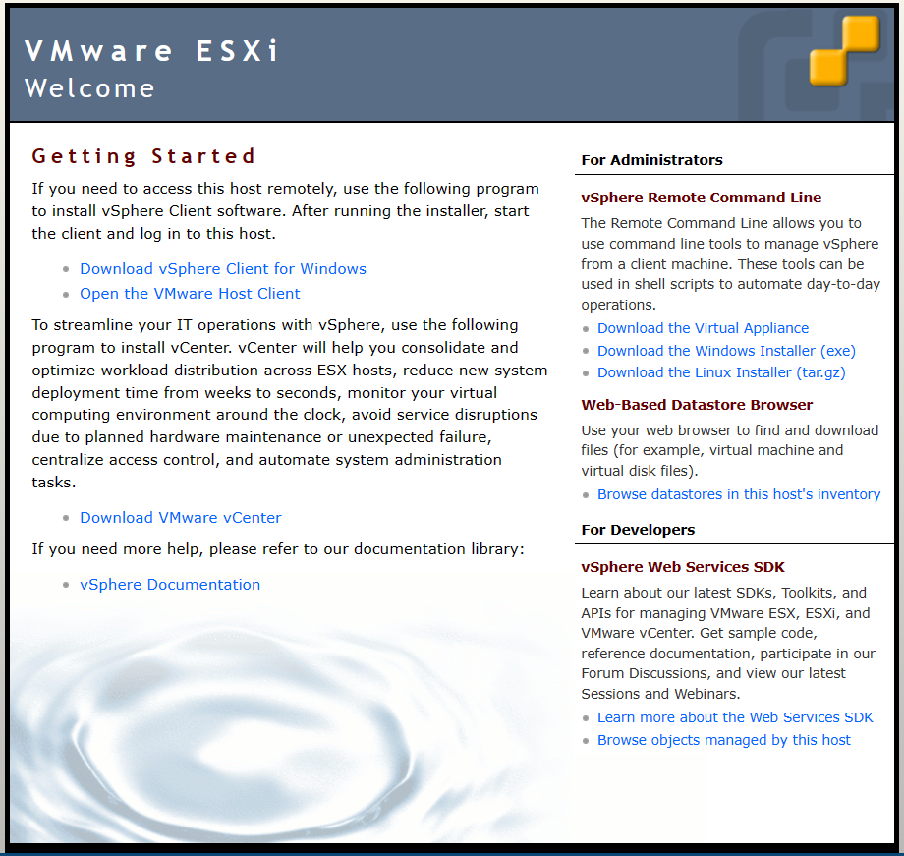

**Remote connection to ESXi host**

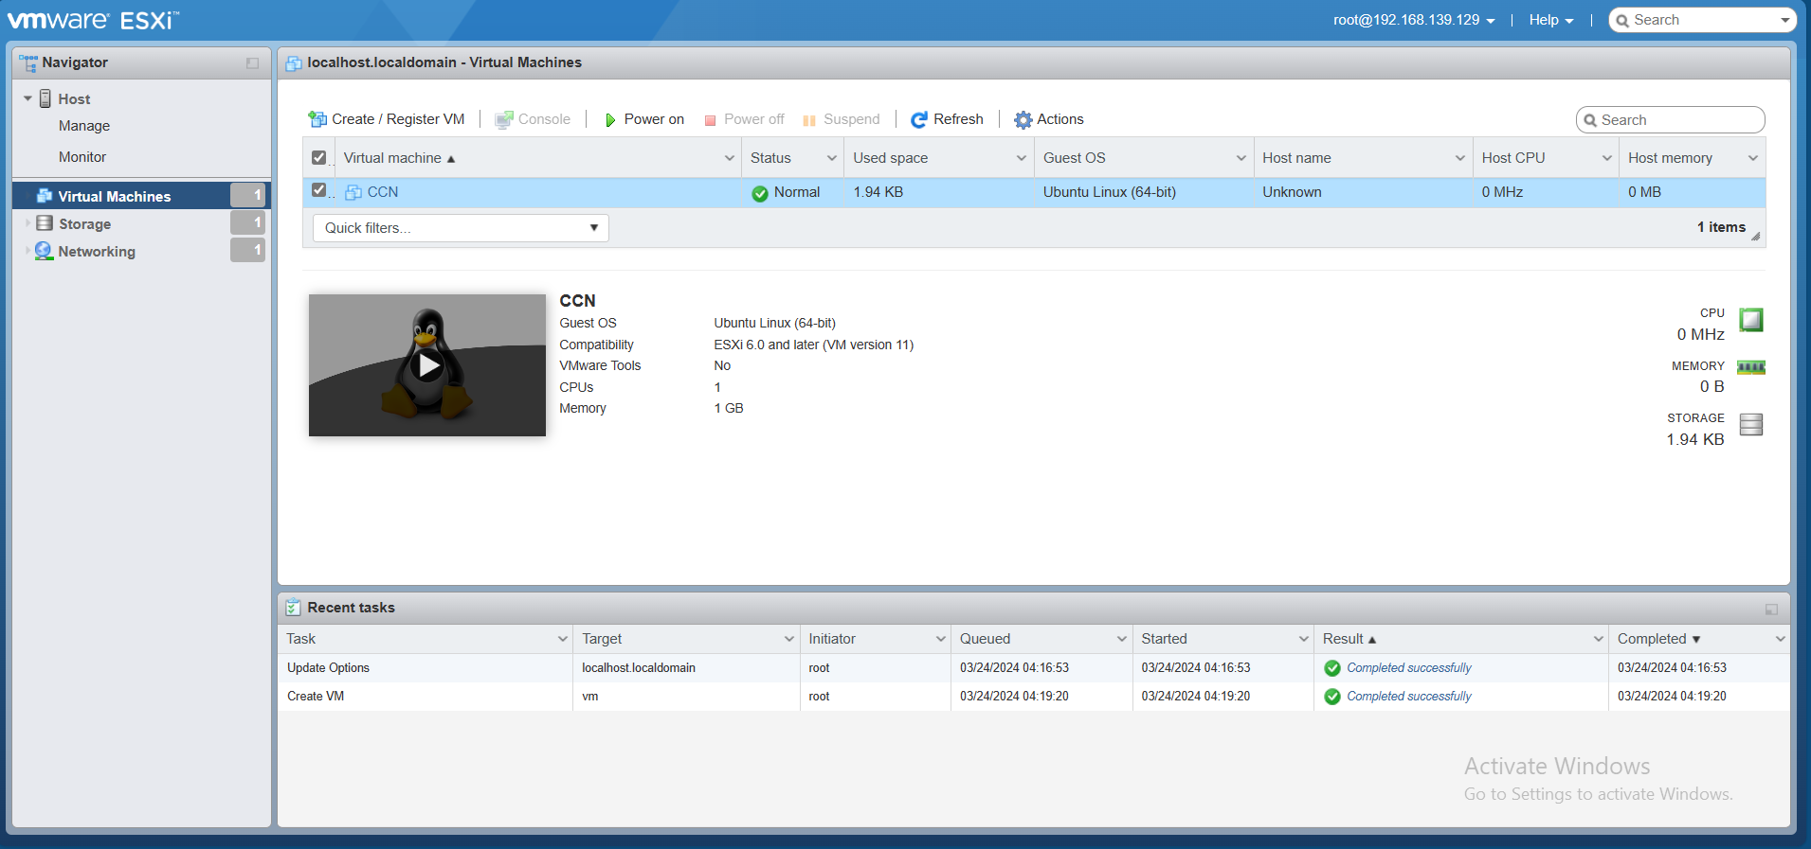

**Create Empty VM on ESXi**

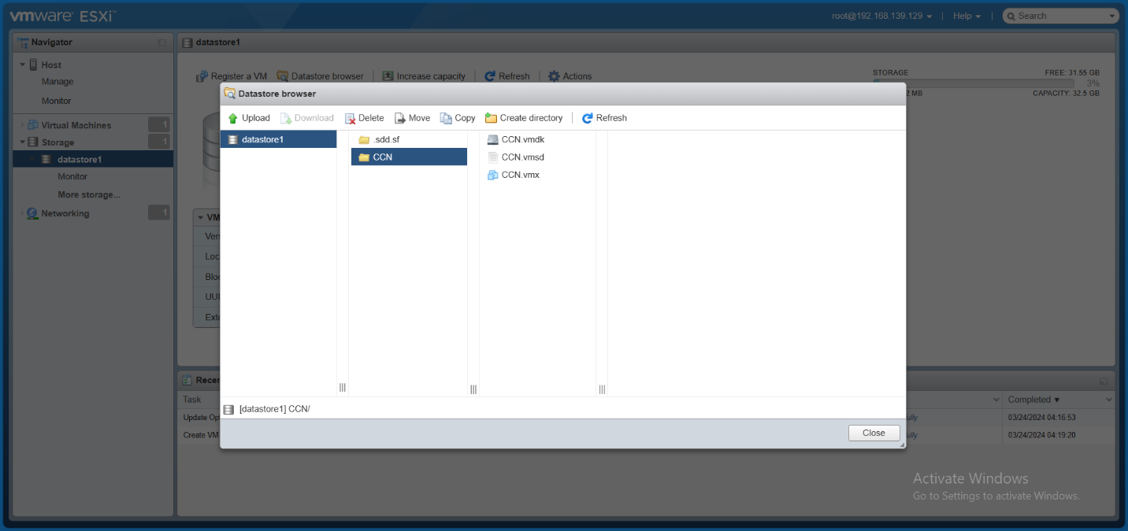

**Datastore**

**صورة تحتوي على برمجيات, نص, أيقونة الحاسوب, برامج الوسائط المتعددة

تم إنشاء الوصف تلقائياً**

**Export VM**